**AWS cloud assignment**

• Create a virtual network with 2 subnets. Each subnet should have 16 Ips only.

Procedure:

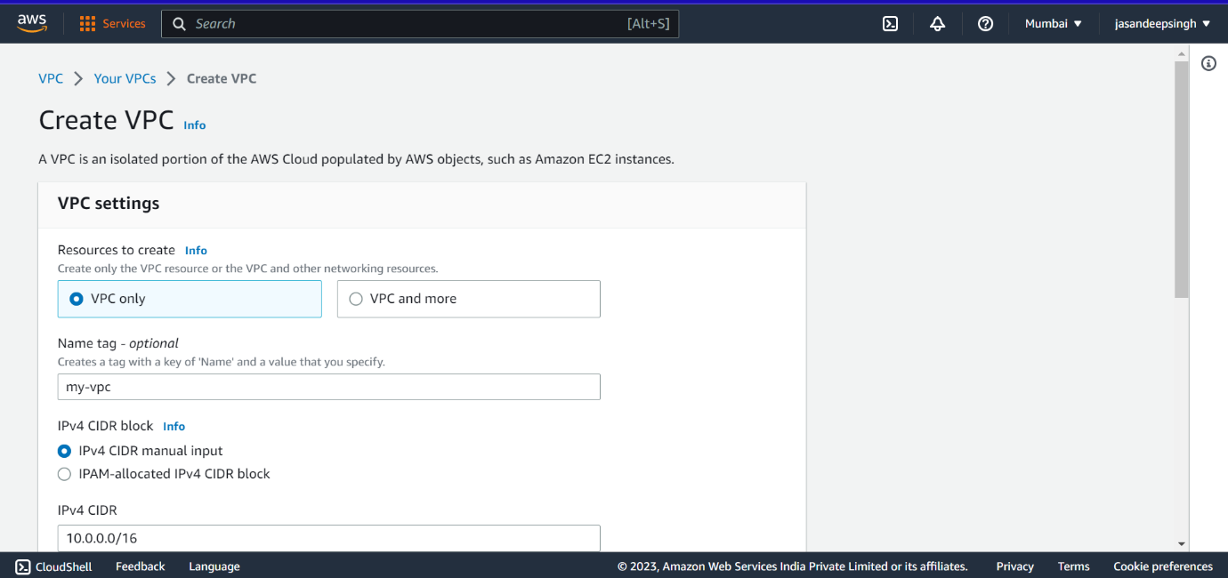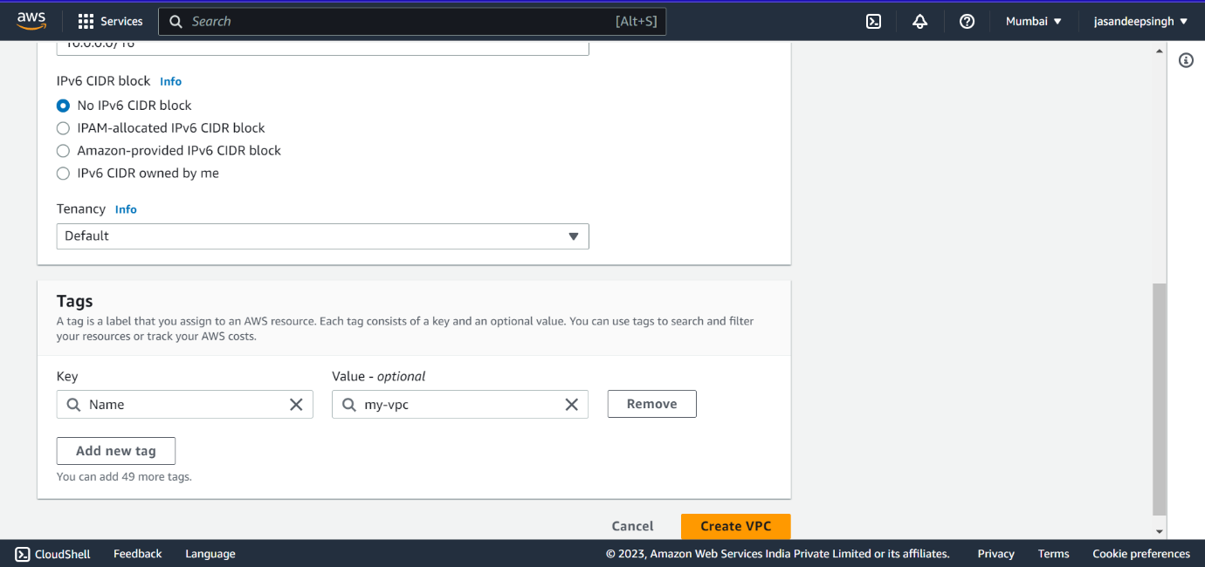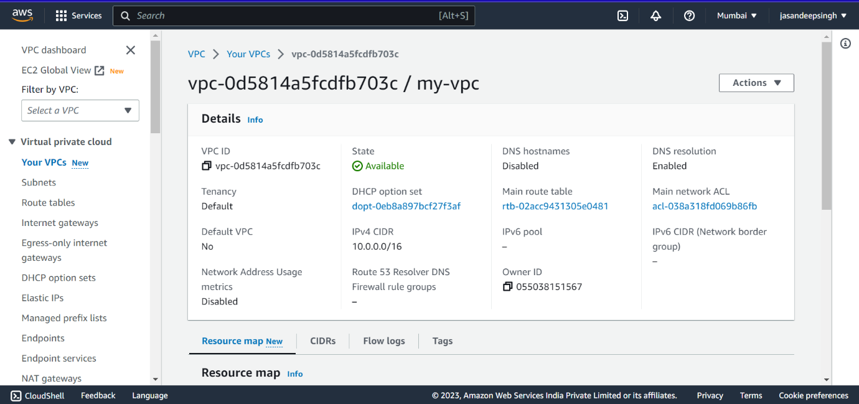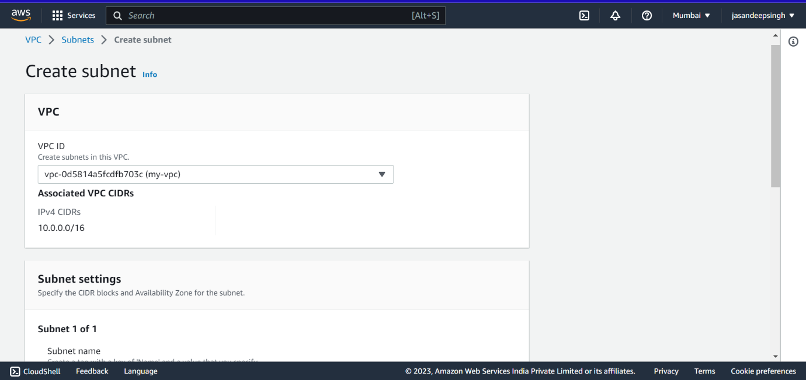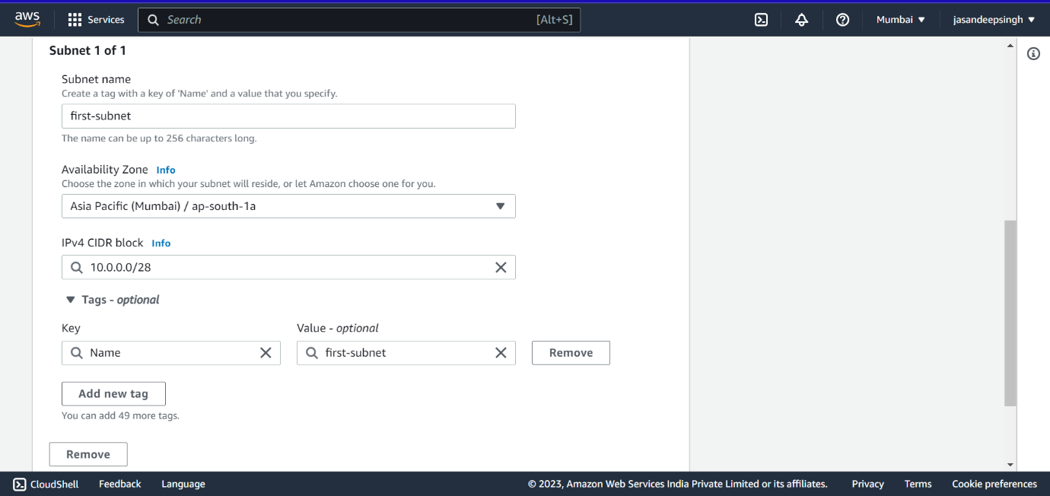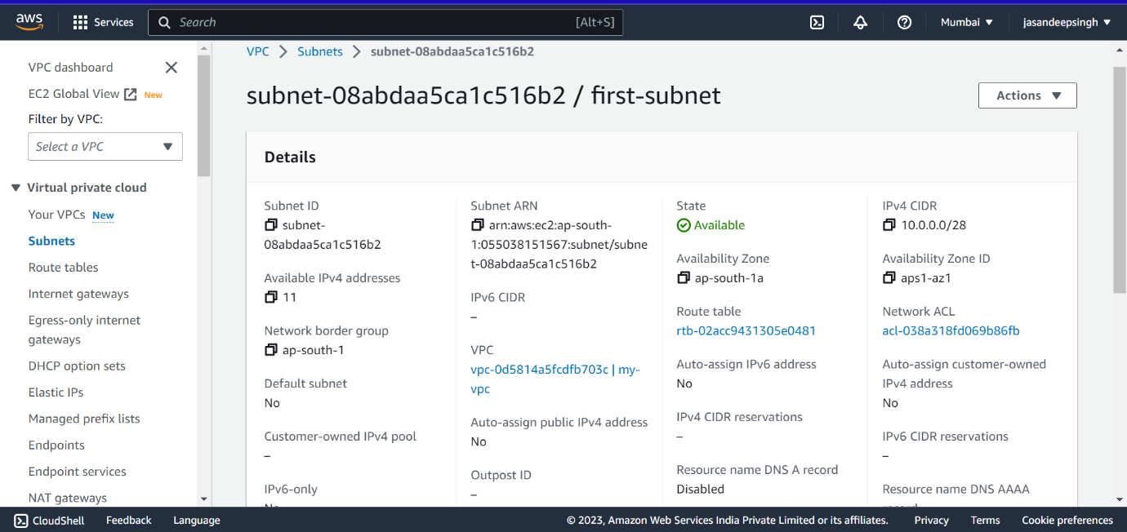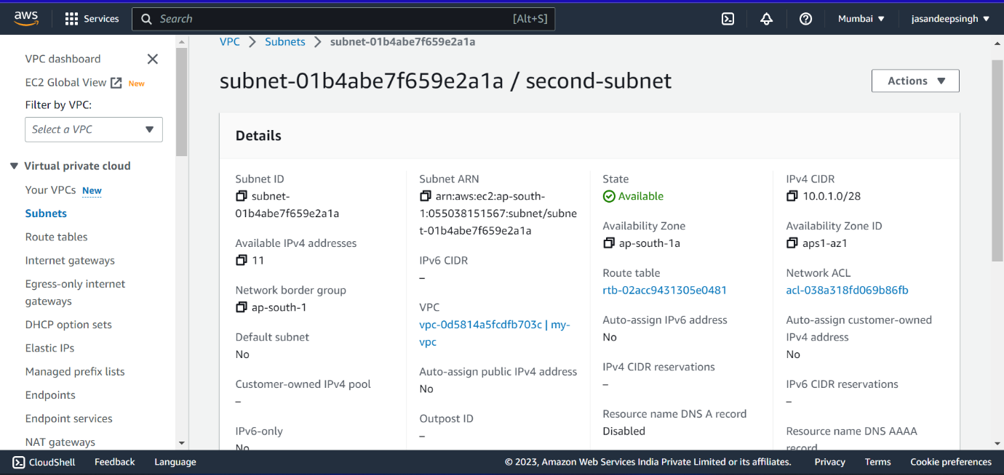

• Inside one of the subnets, create a VM and deploy an application code inside it (any existing application created by you before). Make sure to use appropriate NACLs and SGs.

Procedure:

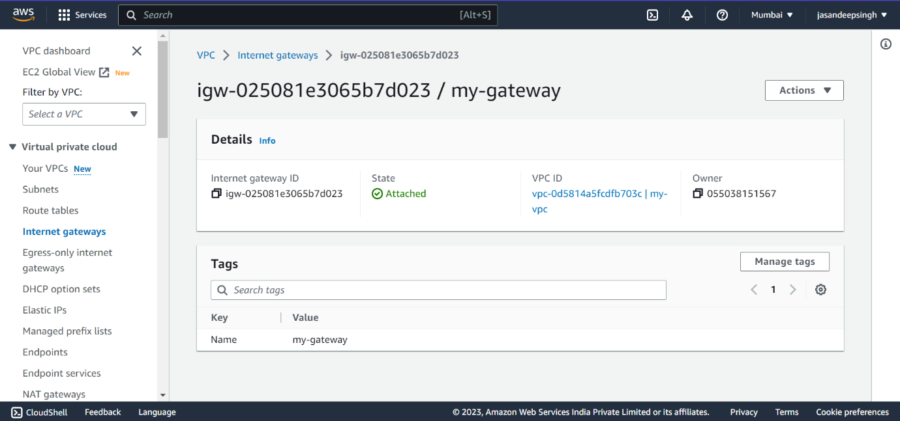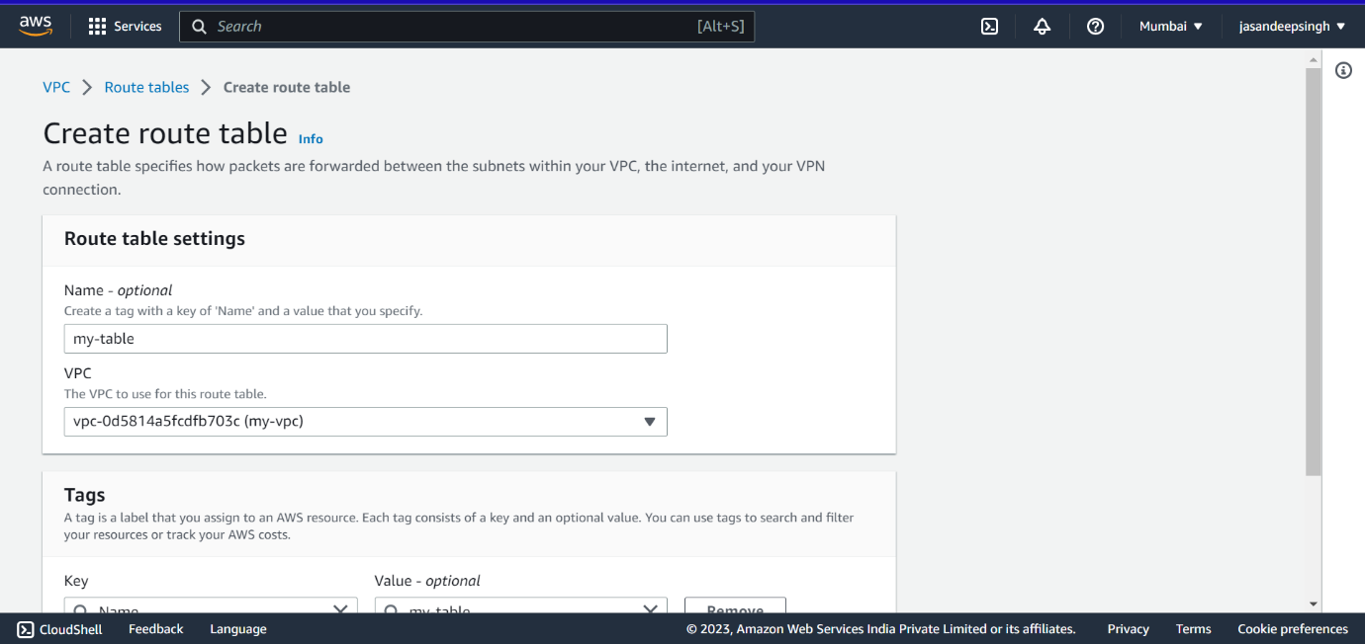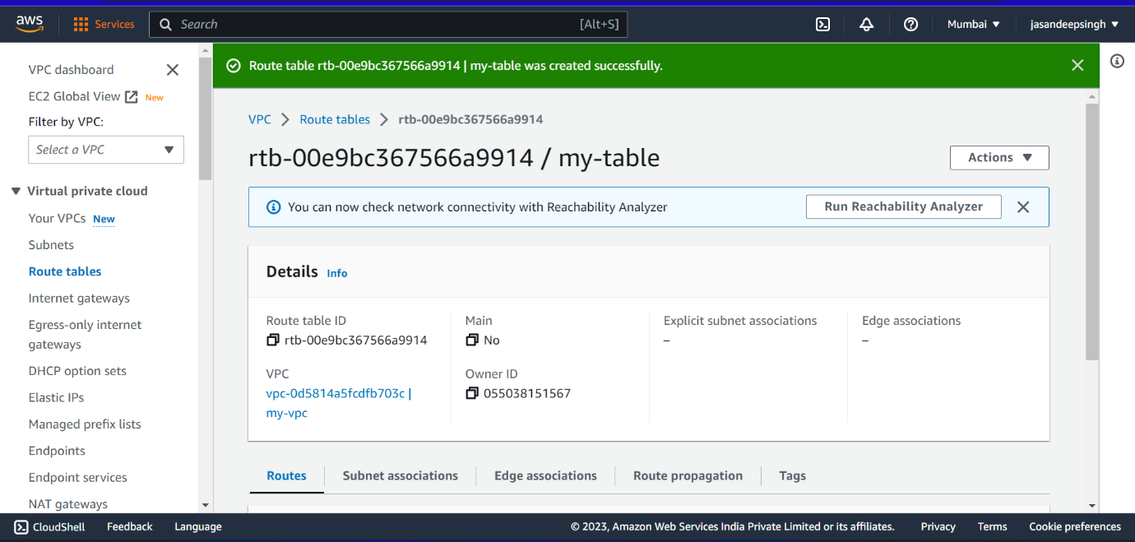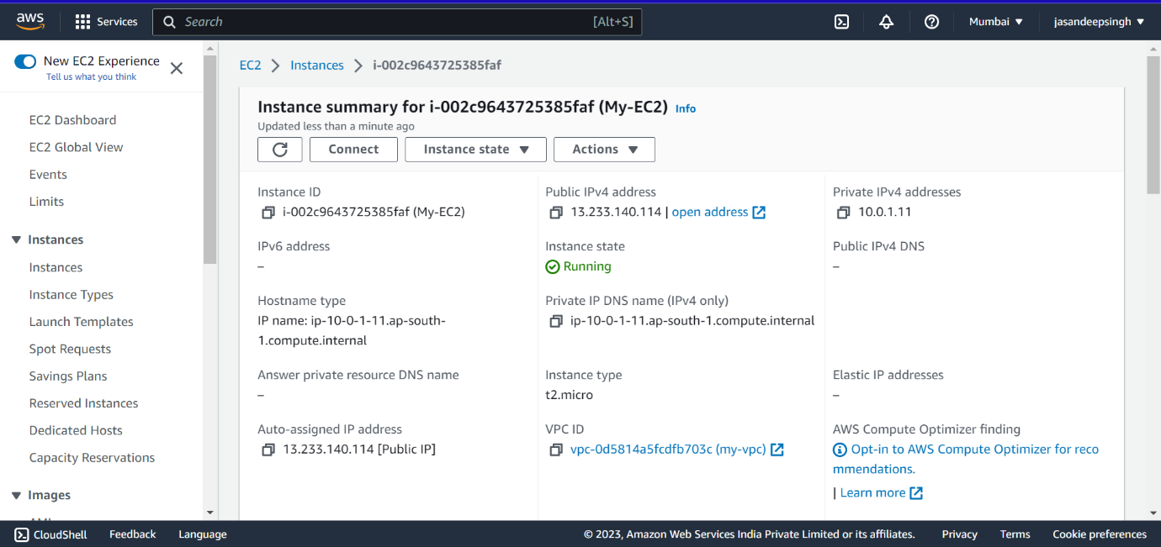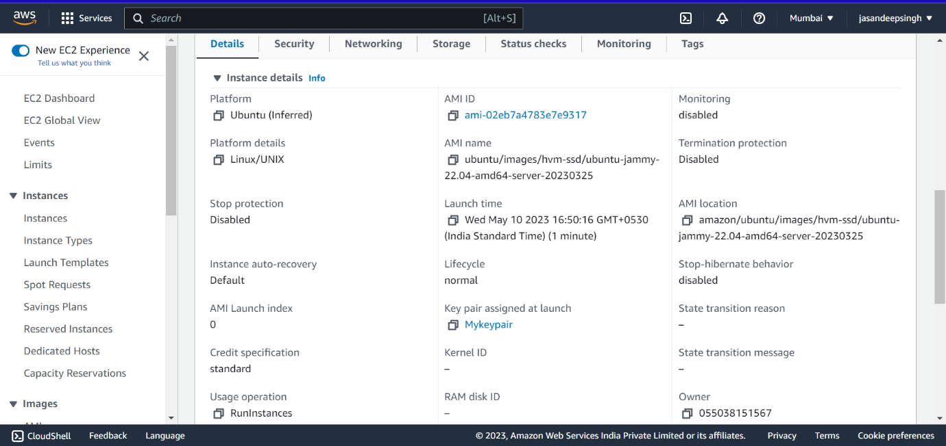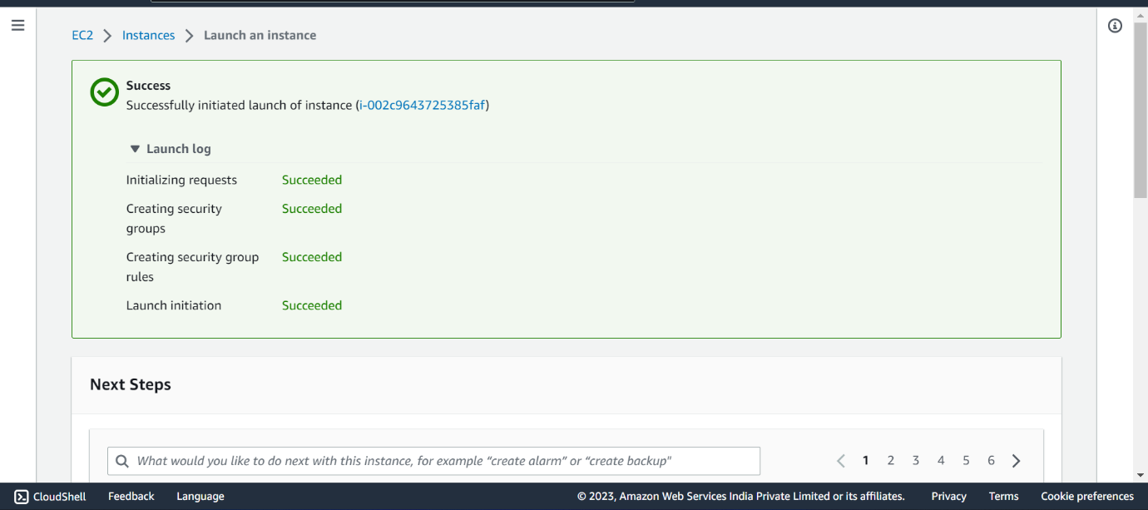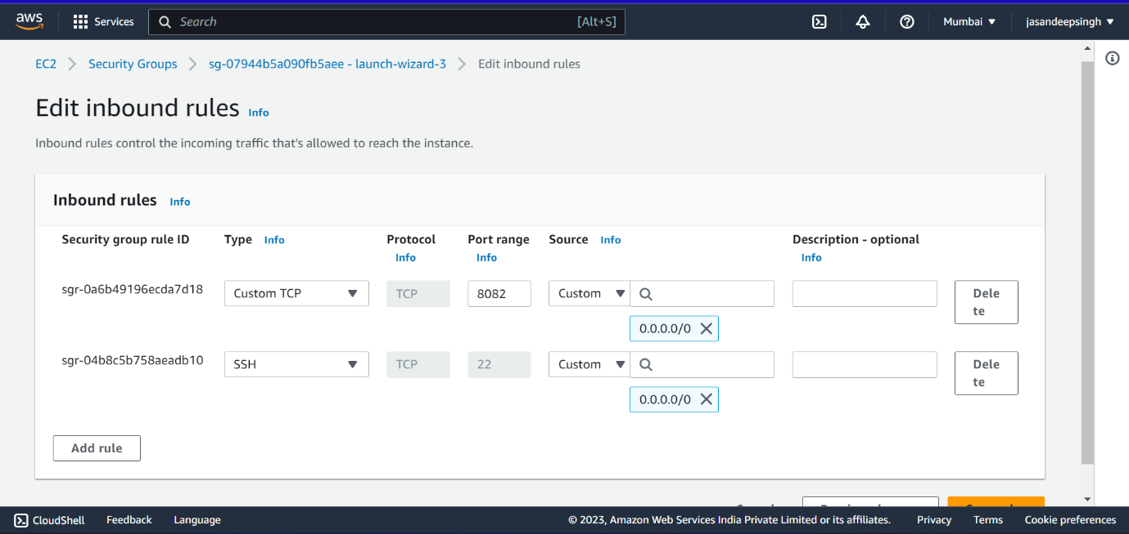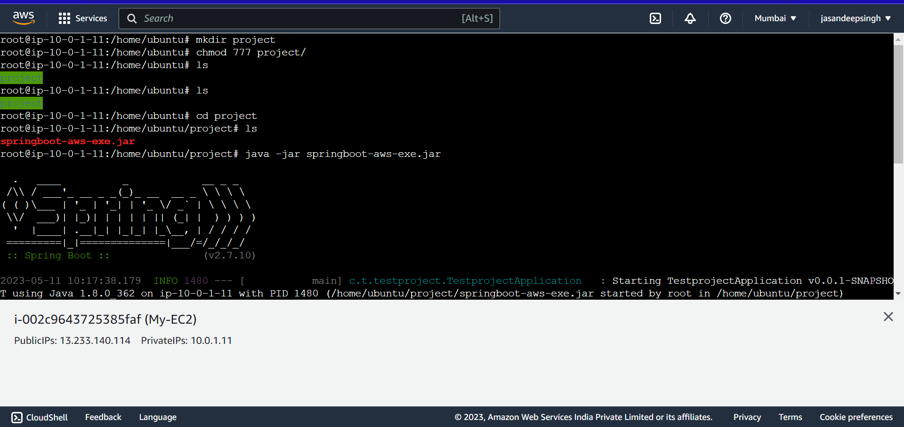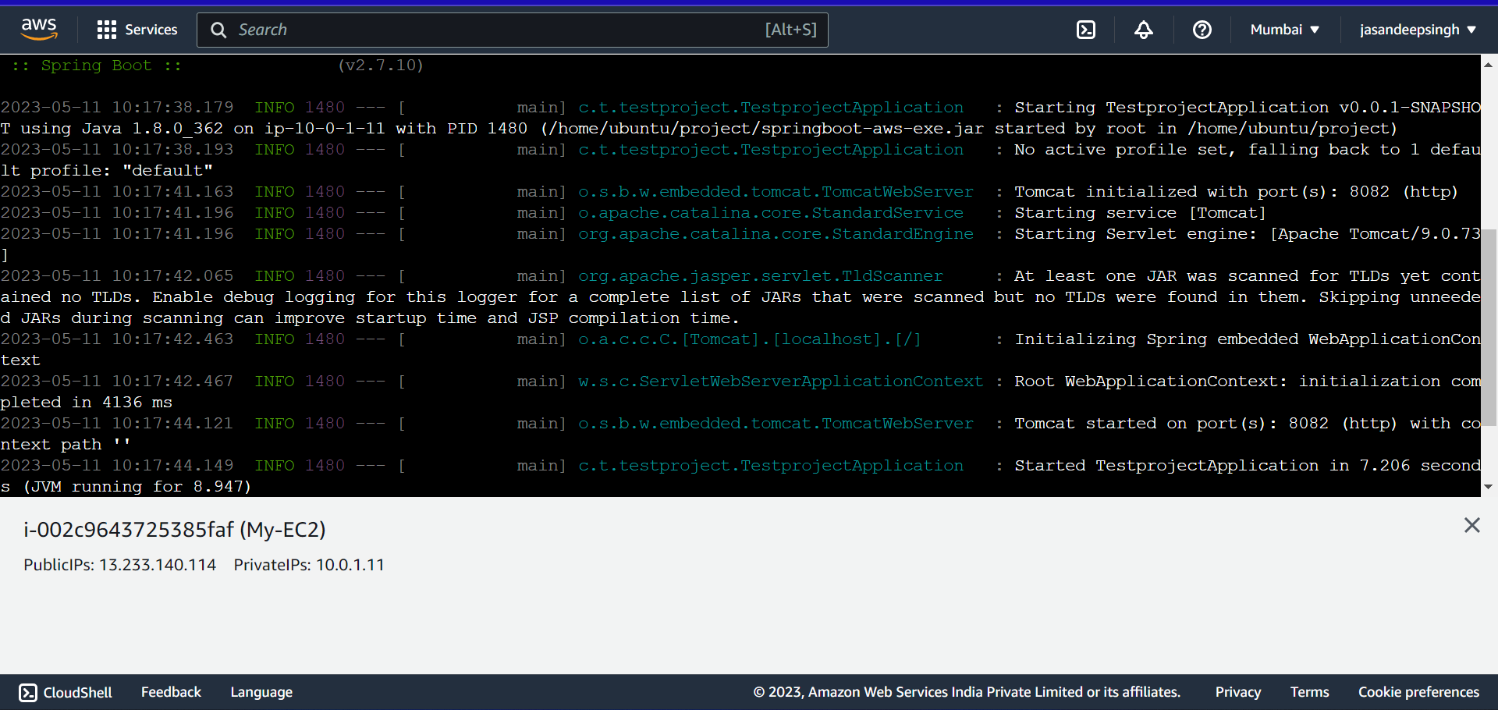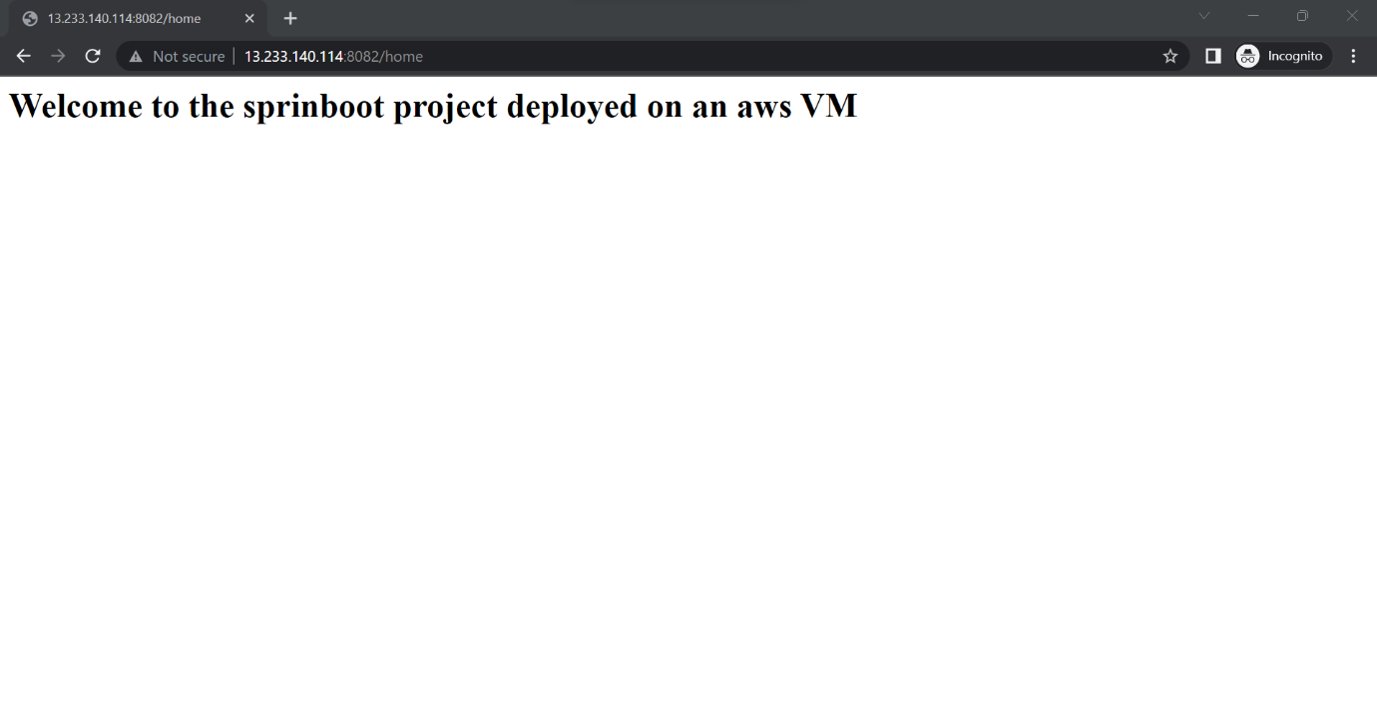

• Deploy the same application to Elastic beanstalk Service.

Procedure:

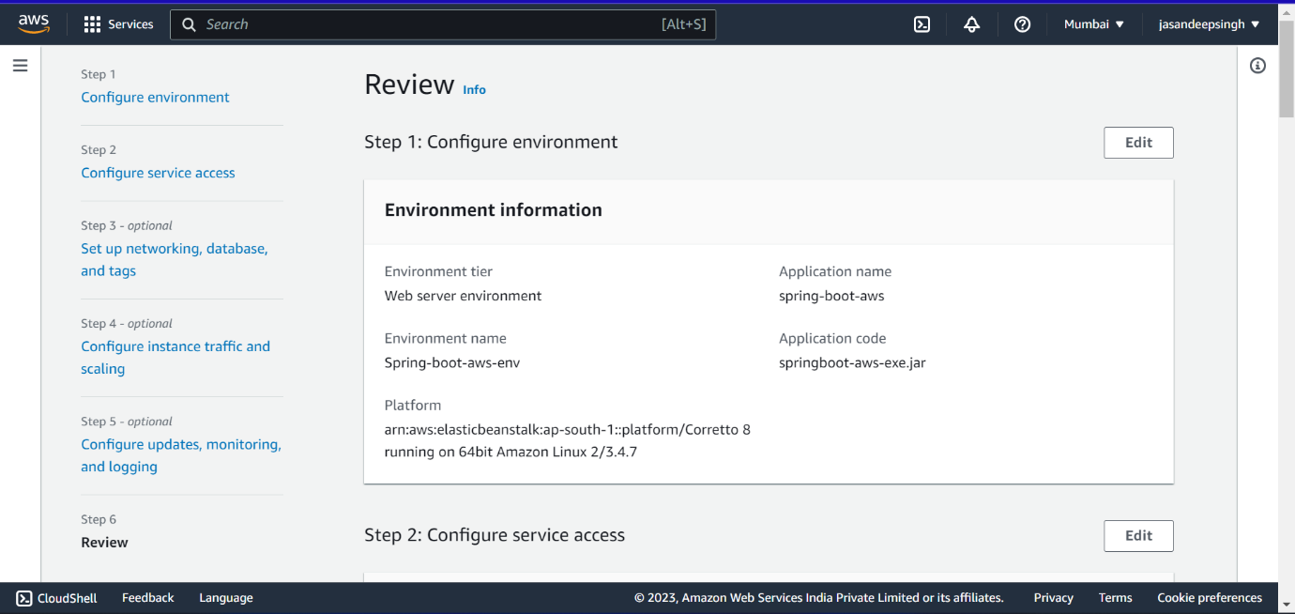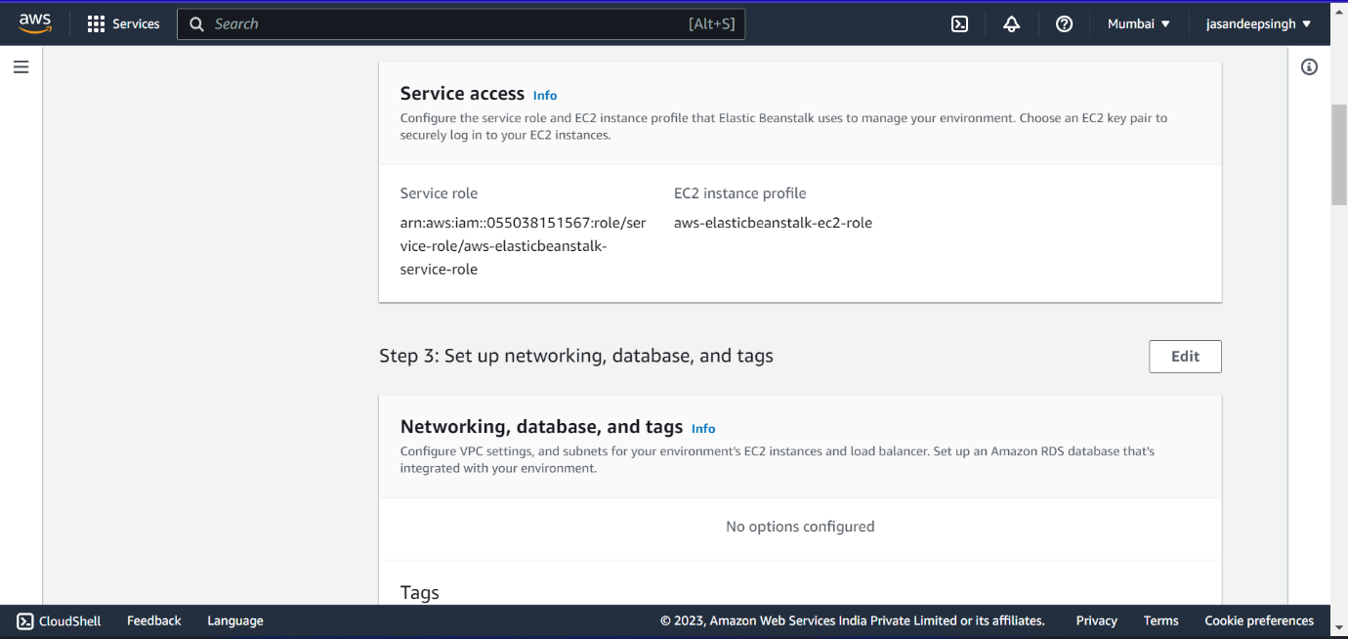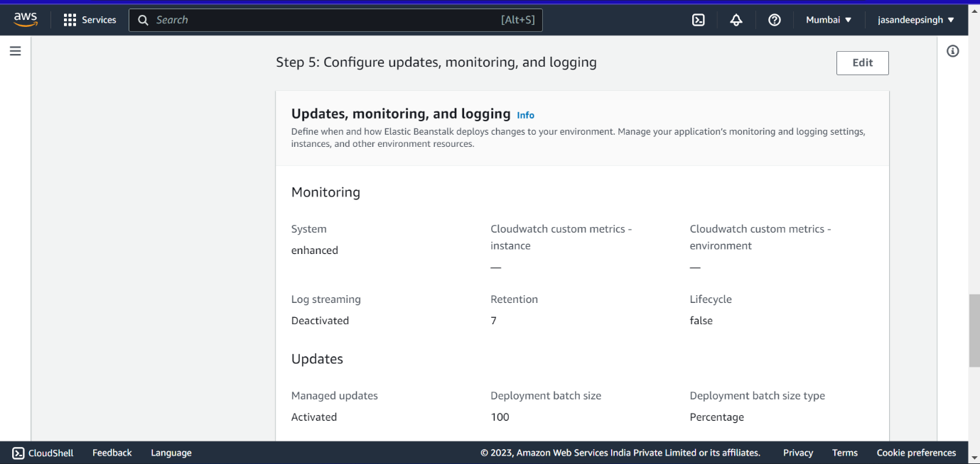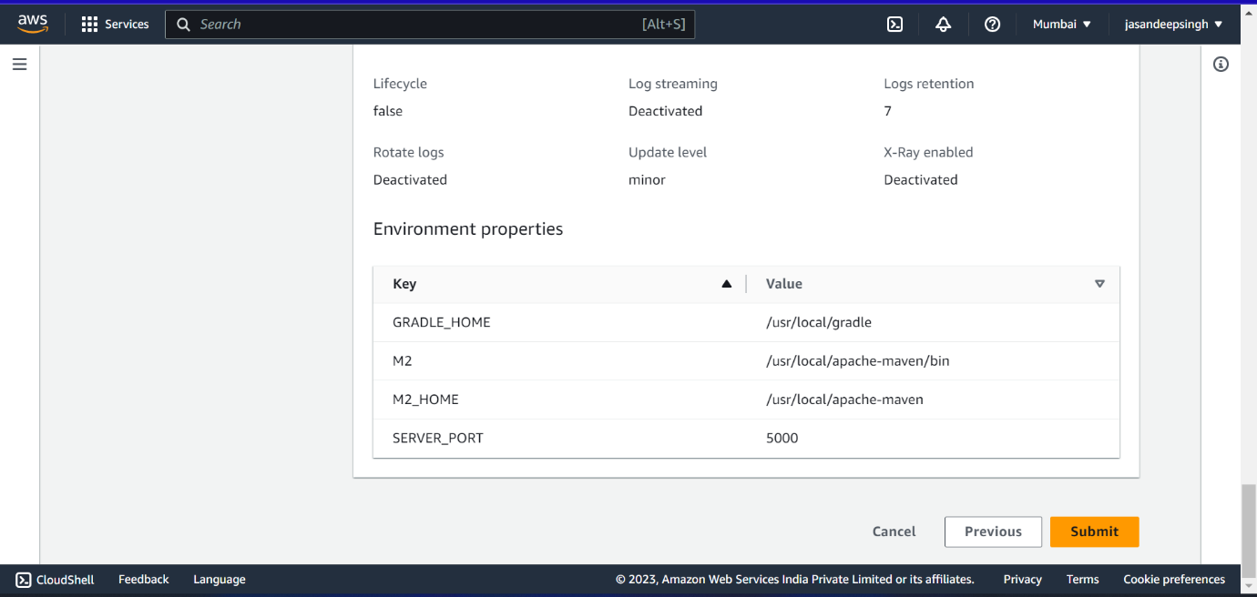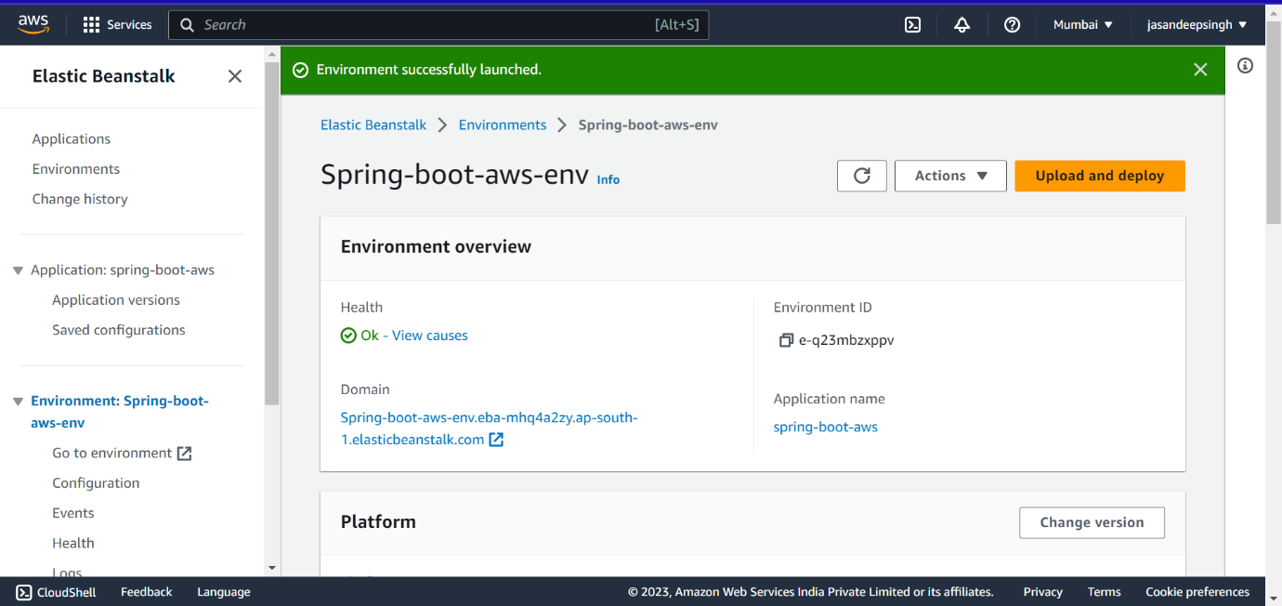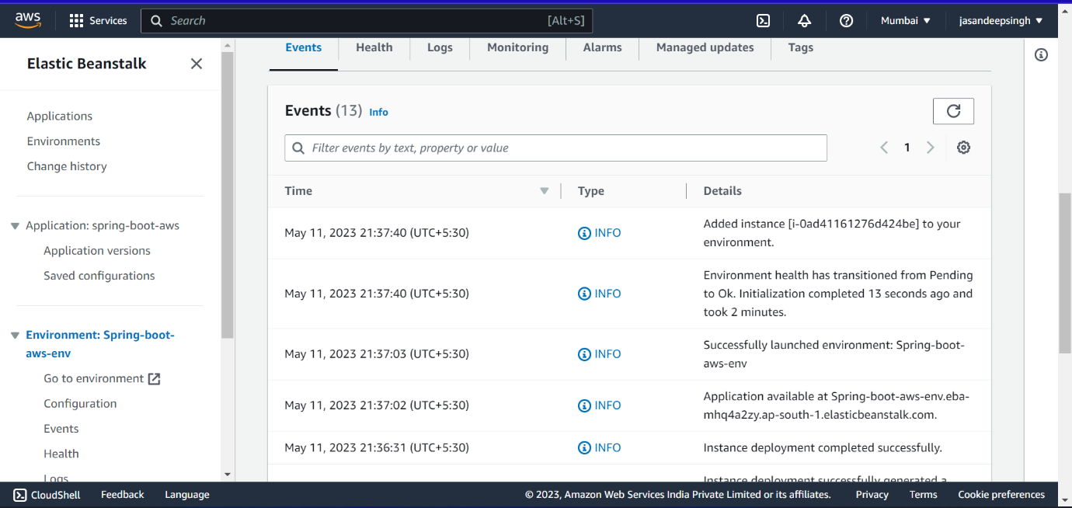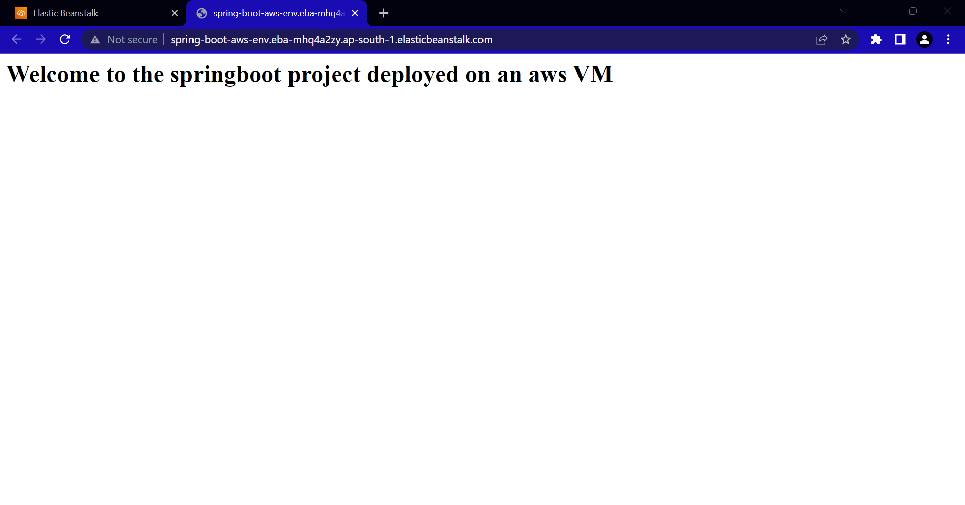

• Create a Lambda that should trigger as soon as you upload a file in the S3 bucket.

Function should be able to print the name of the file uploaded in the function.

Procedure:

